Project Cross Over

The "Cross Over" project was funded by the European Union under the "Europe for Citizens" program.
Its aim was to promote people's awareness of the European Union and to attract their interests to the European Parliament elections in May 2019.
The project involved 14 partners from eleven countries: Croatia, Czechia, Denmark, France, Hungary, Italy, Malta, Poland, Slovakia, Slovenia, and Sweden. In particular, the activities targeted six countries with the lowest turnout in the last EU elections, namely Slovakia, Czechia, Poland, Hungary, Slovenia and Croatia. In these countries, the partner cities or organizations carried out local activities to inform the public, and, as a follow-up, there was an international meeting of all partners to create a unique space for sharing experiences about youth participation.
Twelve activities took place within this project:

Activity 1 - Local activities in Croatia
Participants: The event enabled the meeting of 125 citizens, 125 of whom come from the city of Zagreb (Croatia).
Place / Date: The event took place in Zagreb (Croatia) from 10/01/2019 to 31/01/2019.
Brief description: A creative contest "EU2ME" was launched in which young people thought about what the EU is. They created photographs, videos and literary works. High school debates took place to familiarize students with EU policies, institutions and objectives. Young people also surveyed their attitudes towards the EU.

Activity 2 - International event in Croatia
Participants: 75 people met at the event, 4 of whom come from Novo Mesto (Slovenia), 3 from Zvolen (Slovakia), 1 from Vasteras (Sweden), 4 from Erd (Hungary), 1 from Skopje (Macedonia) , 1 from Brussels (Belgium), 2 from Santa Lucia (Malta), 1 from Reggio Emilia (Italy), 2 from Stockholm (Sweden), 2 from Prague (Czech Republic), 1 from Belgrade ( Serbia), 53 from Zagreb (Croatia).
Place / Date: The event took place in Zagreb (Croatia) from 03/02/2019 to 04/02/2019.
Brief description: Partners and young people gathered in groups to discuss the EU, its mission and values. As part of the event, a conference was held where participants learned about intercultural competences based on the experience of the Croatian partners. The results of the EU2ME competition and other local activities were shared and the winners were awarded.
Photos from Croatian events:
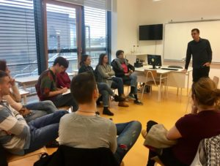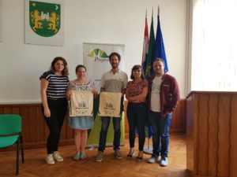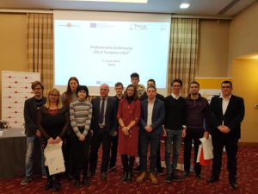

Activity 3 - Local activities in Slovenia
Participants: The event enabled the meeting of 86 citizens, 86 of whom come from Ivančna Gorica (Slovenia).
Place / Date: The event took place in Ivančna Gorica (Slovenia) on 06/03/2019.
Brief description: Citizens and young people attended lectures and worked on EU policies and how they affect people's daily lives. Selected participants in TED presentations presented their experiences and stories about how the EU influenced their lives.

Activity 4 - International event in Slovenia
Participants: The event allowed the meeting of 63 citizens, 2 of whom come from Novo Mesto (Slovenia), 2 from Zvolen (Slovakia), 1 from Vasteras (Sweden), 2 from Erd (Hungary), 1 from Brussels (Belgium) ), 2 from Reggio Emilia (Italy), 2 from Stockholm (Sweden), 2 from Prague (Czech Republic), 1 from Paris (France), 1 from Aarhus (Denmark), 3 from Zagreb (Croatia) ), 44 from Ivančna Gorica (Slovenia).
Place / Date: The event took place in Ivančna Gorica (Slovenia) from 15/03/2019 to 16/03/2019.
Brief description: The results of local activities were shared with the participants and they then discussed the key policies that the EU deals with using the focus groups and world café approach. An EU market program was also prepared, where the EU and its policies were presented to the wider public.
Photos from Slovenian events:
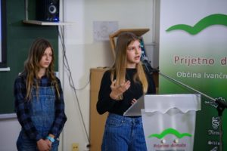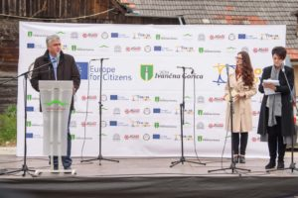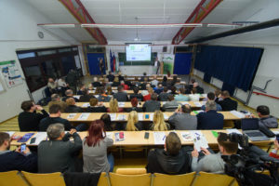

Activity 5 - Local activities in Slovakia
Participants: The event enabled 205 citizens to meet, 205 of whom come from Zvolen (Slovakia).
Place / Date: The event took place in Zvolen (Slovakia) from 01/04/2019 to 10/04/2019.
Brief description: In the framework of “the Citizen Participation Week” different activities were organized: an art competition, as well as discussions, workshops, film screenings, and more to help identify key EU challenges and discuss possible future scenarios.

Activity 6 - International event in Slovakia
Participants: The event allowed 84 people to meet, 2 of whom come from Novo Mesto (Slovenia), 3 from Erd (Hungary), 1 from Vicenza (Italy), 2 from Stockholm (Sweden), 2 from Prague (Czech Republic) republic, 1 from Paris (France), 2 from Aarhus (Denmark), 4 from Zagreb (Croatia), 1 from Ivančna Gorica (Slovenia), 2 from Penne (Italy), 2 from Gdansk (Poland) , 61 from Zvolen (Slovakia).
Place / Date: The event took place in Zvolen (Slovakia) from 11/04/2019 to 12/04/2019.
Brief description: Groups representing local representatives, civil society organizations and young people first discussed some of the EU's major challenges, and also played a game to evaluate strategies that could be addressed by the EU challenges and designed by participants in local activities. The results of local activities were presented, the best artworks were awarded and a conference was organized.
Photos from Slovak events:
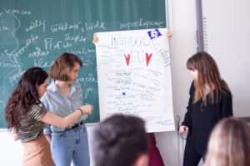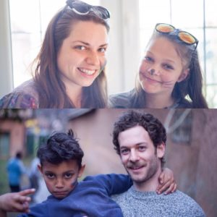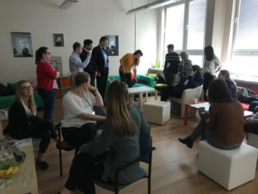

Activity 7 - Local activities in the Czech Republic
Participants: The event enabled the meeting of 115 citizens, 115 of whom come from Prague.
Place / Date: The event took place in Prague (Czech Republic) from 18/03/2019 to 03/05/2019.
Short description: Workshops and debates took place. In preparation for these debates, students gathered information from various online and printed sources and analyzed it, also as “journalists”, they asked people to get deeper into the topic and get their feedback. They participated in several debates on controversial topics.

Activity 8 - International event in the Czech Republic
Participants: The event allowed 77 people to meet, of which 2 come from Novo Mesto (Slovenia), 2 from Zvolen (Slovakia), 2 from Erd (Hungary), 1 from Santa Lucia (Malta), 3 from Reggio Emilia (Italy), 2 from Stockholm (Sweden), 1 from Paris (France), 2 from Aarhus (Denmark), 2 from Zagreb (Croatia), 2 from Ivančna Gorica (Slovenia), 2 from Penne ( Italy), 2 from Gdansk (Poland), 3 from Vicenza (Italy), 51 from Prague (Czech Republic).
Place / Date: The event took place in Prague (Czech Republic) from 20/05/2019 to 21/05/2019.
Brief description: Results of previous local activities were presented. Participants in the so-called talk show presented pre-election scenarios, pre-election preferences and Eurosceptic propaganda in their countries. Participants worked deeper on the topic of European elections and Euroscepticism.
Photos from Czech events:

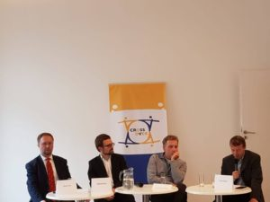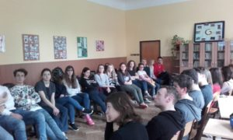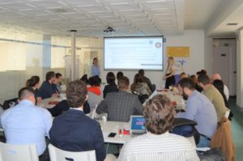

Activity 9 - Local activities in Hungary
Participants: The event allowed the meeting of 20 citizens, 20 of whom come from Erd (Hungary).
Place / Date: The event took place in Erd (Hungary) on 29/04/2019.
Short description: The participants were acquainted with how the European Parliament works, what is its agenda and political parties. The topics of the democratic deficit, the EU Parliament and its political parties were discussed. The participants were divided into groups in which they played the role of different political parties and debated current EU issues.

Activity 10 - International event in Hungary
Participants: The event allowed the meeting of 41 citizens, of which 1 come from Brussels (Belgium), 4 from Santa Lucia (Malta), 1 from Reggio Emilia (Italy), 2 from Prague (Czech Republic), 2 from Aarhus (Denmark), 2 from Zagreb (Croatia), 2 from Penne (Italy), 2 from Gdansk (Poland), 3 from Vicenza (Italy), 23 from Erd (Hungary),
Place / Date: The event took place in Erd (Hungary) from 11/06/2019 to 12/06/2019.
Short description: A conference was held to provide more information on the EU and the European Parliament. Partners and other participants took part in the program, simulating the role of MEPs. In the groups according to the various commissions, they made proposals, later presented them and voted on them.
Photos from Hungarian events:

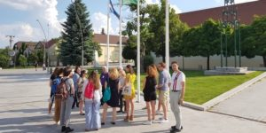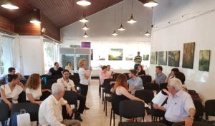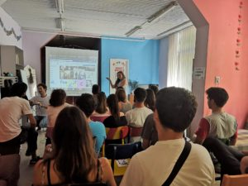

Activity 11 - Local activities in Poland
Participants: The event enabled 144 citizens to meet, 144 of whom come from Gdansk (Poland).
Place / Date: The event took place in Gdansk (Poland) from 24/04/2019 to 28/05/2019.
Short description: Calls for campaigns to promote greater political engagement in EU affairs and greater civic engagement among young people were launched and were addressed by youth groups and campaigning. They invented slogans, posters and videos. The best campaigns were presented on the social networks of the Association and publicly displayed. A march took place.

Activity 12 - International event in Poland
Participants: The event allowed the meeting of 75 citizens, of which 2 come from Novo Mesto (Slovenia), 4 from Zvolen (Slovakia), 2 from Erd (Hungary), 1 from Santa Lucia (Malta), 2 from Reggio Emilia (Italy), 2 from Prague (Czech Republic), 1 from Paris (France), 2 from Aarhus (Denmark), 2 from Zagreb (Croatia), 2 from Ivančna Gorica (Slovenia), 3 from Vicenza (Italy), 52 from Gdansk (Poland).
Place / Date: The event took place in Gdansk (Poland) from 08/07/2019 to 09/07/2019.
Brief description: Results of local activities were presented, the best youth campaigns were awarded. The partners evaluated the results of the project and exchanged examples of good practice from activities implemented at the local level in order to promote young people's involvement and interest in the EU. The possibilities for further cooperation were explored.
Photos from Polish events:
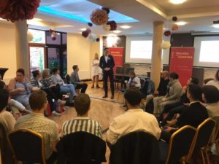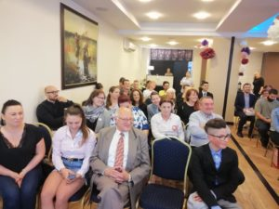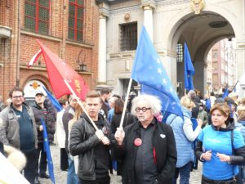

You can read more about the project on the Crossover website at one of the ALDA partners.

