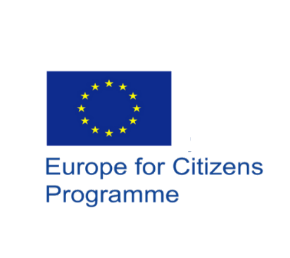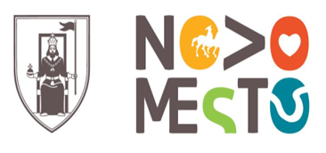
Project ‘Building societies without racism”
Citizens, Equality, Rights and Values
Program (CERV) Network of Towns

ENENT 3o – Novo Mesto, Slovenia SLOVENIA 24-27 August 2023

Cooperation with the European Commission was claimed and achieved by the Social and Cultural Organization of the Municipality of Delta - KPODD. The European Commission approved KPODD's request for €145,000 in funding to organize and implement in five European municipalities, among them at Novo Mesto Municipality, a program concerning the Rights, Equality and Values of citizens entitled "Building societies without racism».

At the event in Slovenia two topics was discussed. The first one “Promotion of cultural diversity and strengthening of intercultural dialogue” by representatives of Slovenia, Malta, Bulgaria, Spain, Belgium, Portugal, Estonia, Hellas. Intercultural dialogue is a process involving an open and respectful exchange or interaction between individuals, groups and organizations with different cultural backgrounds or worldviews. It is important to dwell on the dynamic particularities of different cultures.

The second topic “Support for victims of racism and discrimination. “was discussed by representatives of Sweden, Italy, Hungary, Denmark, France, Cyprus. they analyzed, they expressed their opinions and they presented good practices how a deeper understanding of different perspectives can be developed, how can freedom be empowered, how can equality be promoted, and how can creative processes be enhanced.

The relevant two topics discussion was held in the presence of Urban Kramar Deputy Mayor of Novo mesto, Ms. Branka Bukovec - President of DRPDNM, Tina Cigler, Secretary General of DRPDNM, Mitja Bukovec - Project manager at DRPDNM and the delegation of KPODD President Mr. Alexandros Diamantopoulos, the Mayor of Municipality of Siggiewi in Malta, Mr. Dominic Grech and Deputy Mayors Mr. Demetris Demetriou and Andreas Gregoriou from Agios Dometios Municipality of Cyprus.

An intervention was made by Tina Cigler, Secretary General of DRPDNM, Ms. Also, the representatives of organizations participated in the discussion.

DRPDNM undertook the organization of the conference, which he carried out with great success. Many citizens, organizations and institutions of the place attended and followed the work of the conference.
All participants received an excellent welcome from the organization DRPDNM. They had the opportunity to take a guided tour of the beautiful city of Novo Mesto, to travel through its history and culture, to taste local dishes and to enjoy the wine of the region.
