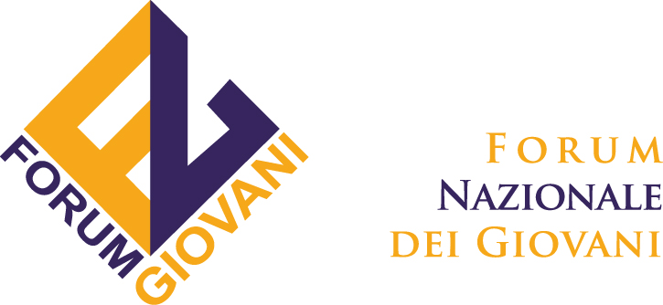

Inter-cultural mediation skills for Social Inclusion and Mediterranean Youth Dialogue -
a National Youth Councils educational approach

Background of the Training for facilitators
The training proposed is an important step for FNG which involve the whole platform representing the Italian youth organizations and all its structure.
This training is going to be realised in the middle of and intense year where FNG is finally making the most of all the synergies and cooperation with the other European National Youth Councils and with the organizations which operate within the framework of youth policies, training and intercultural learning.

The training “Intercultural Mediation skills for social inclusion and Mediterranean youth dialogue” aims to train facilitaors and youth leaders running thematic workshops on Euro-Arab issues within the framework of Youth in Action Programme.

Being aware that in European societies cultural, legislative and social differences are very deep, young people believe that is of primary relevance to establish an active and fruitful dialogue on importance issues that globalization challenges and economical crisis propose them, such as sustainable development, migration and, therefore, the need to establish a common educational framework in order to facilitate the social inclusion process of young people with extra-European background in Europe.

Social exclusion of young people with extra-European background in Europe is the result of a lack of communication and mutual knowledge, that often determines conflicts among communities which share social spaces but don't communicate with each other, creating stereotypes and prejudices that might become conflicts.

Conflicts are also determined by the different access to education, to cultural activities and active social participation in a country. In order to change the trend, where some young people are forced to marginalised jobs often linked with illegal activities, it is fundamental that young people start creating opportunities where “foreigners” are perceived as a resource for the community and not as a threat.

For this reason we believe it is very important for European youth facilitators to meet and to practice together with Arab facilitators, in order to improve their intercultaral mediation strategies that will enhance the dialogue and the mutual comprehension through conflict resolution activities among young people to provide a signal to the rest of society.

Aims of the training course
The training aims to share non formal education practices among the facilitators coming from the European National Youth Councils in order to facilitate the workshops of the Mare Nostrum Euro-Arab Youth Event.

Objectives:
- to share perspectives and educational tools that facilitate the social inclusion process of people with migration background in EU countries, within the frame of the European Year for Combating Poverty and Social Exclusion
- to identify common non formal educational approaches when dealing with conflict resolution and social inclusion in EU countries on a Mediterranean relationships perspectives.
- to facilitate the development of youth policies and youth participation both at national and international level.
- to provide participants with concrete tools in a comfortable environment to apply non formal methods in order to become multipliers and facilitators of processes in group dynamics
- to approach the priority issues of the YIA programme (youth active participation/global challenges and social inclusion) among young people coming from different realities and working or volunteering background in order to find a common guideline and facilitation methodology.

Expected results
- to create a follow up of the one year project “National Youth Councils Training Cooperation” giving the chance to 2 participants for each national pool of trainer to meet and to share good practices about non formal educational strategies
- to provide a creative environment where youth facilitators will have the opportunity to practice facilitating workshops together with Arab facilitators within the event Mare Nostrum, which will start just at the end of the TC
- to give visibility to the National Pool of Trainers to to the key role that non formal education plays in every context of youth participation, permanent priority of YiA Programme
- to promote Life-Long Learning process to enhance young people key competences to improve their quality of life
- to strengthen cooperation on global issues among National Youth Councils

Training methodology
The Training is designed as a process of mutual learning through a set of tools of non formal education, where participants will have the opportunity to share their educational approaches planning and facilitating the workshops within the frame of the first Euro-Arab Youth Event.

Languages
The different sessions of the Course will be in English, candidates are requested to
speak fluent English.

The dates
Therefore, the final dates of the training will be from the 19th to the 25th of July, but participants will be required to prolong their staying until the 30th of July in order to take part to the Euro-Arab Youth Event.

Due to financial restrictions the Advanced Preliminary Visit won't take place.

The venue
The training will take place in the wonderful environment of Marina di Ragusa in Sicily, which is about 15 km from Ragusa.

Participants will be lodged in the Hotel Baia del Sole (www.hotelbaiadelsole.it/). The hotel has private beach and a swimming pool where it will be possible to relax during free time. The activities will take place in house. The village, which has a nice sea port, is about 10 minutes walking distance from the hotel.

Travel and local transportation
Participants are required to travel to Catania's airport where FNG staff will arrange bus transfers to get to Marina di Ragusa. It takes about 1 hour to trip from the airport to the hotel.

Special needs
Participants with any kind of special needs are required to express them in the application form.

Reimbursement procedures
The reimbursement procedures will take place directly to partner organizations. Boarding passes have to be sent to FNG within a month after the training in order to proceed with payments.

FNG will reimburse 70 % of travel costs as in the Youth in Action Programme financial agreement.

Participant are required to take the cheapest means of transportation in order not to exceed with the budget.

